ICE Task 1

ST10305921

Zoe Heyneke

**Question 1**

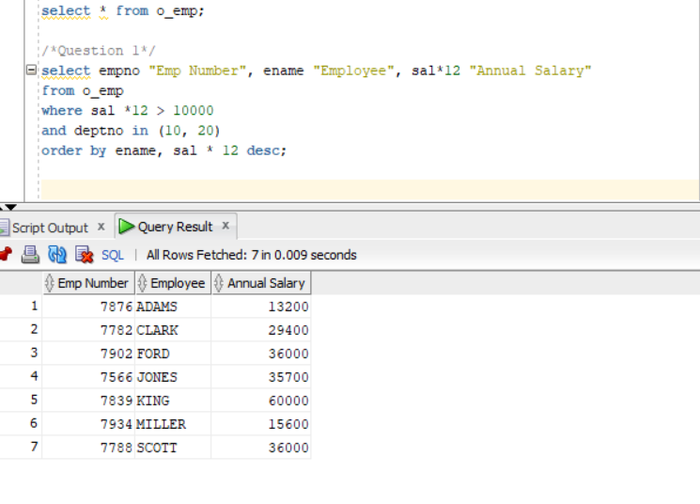

**Question 2**

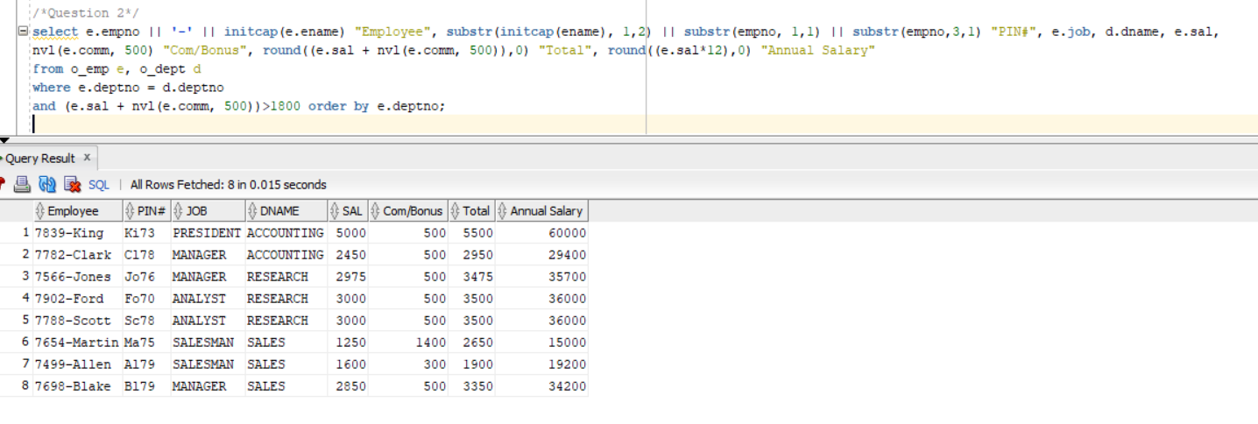

/*Question 2*/

select e.empno || '-' || initcap(e.ename) "Employee", substr(initcap(ename), 1,2) || substr(empno, 1,1) || substr(empno,3,1) "PIN#", e.job, d.dname, e.sal,

nvl(e.comm, 500) "Com/Bonus", round((e.sal + nvl(e.comm, 500)),0) "Total", round((e.sal*12),0) "Annual Salary"

from o_emp e, o_dept d

where e.deptno = d.deptno

and (e.sal + nvl(e.comm, 500))>1800 order by e.deptno;

**Question 3**

**Question 4**

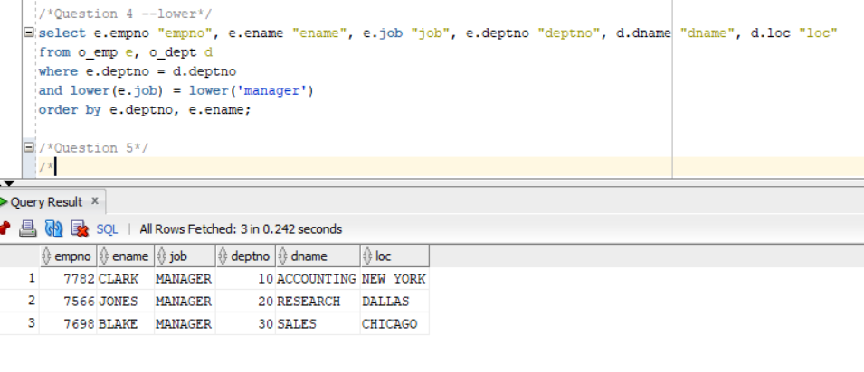

**Question 5**

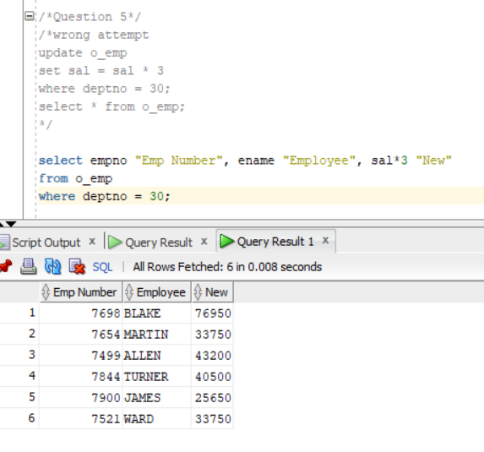

select empno "Emp Number", ename "Employee", sal*3 "New"

from o_emp

where deptno = 30;

**Question 8**

8.1

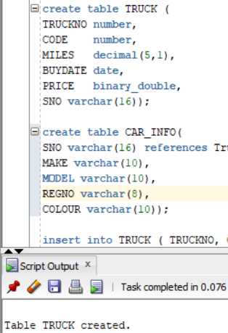

8.2

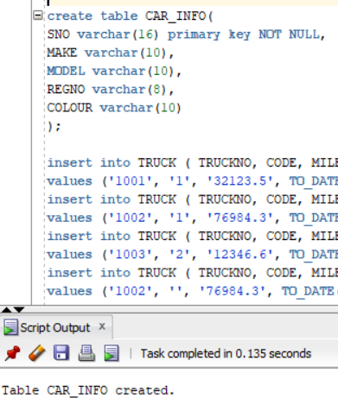

**Question 9**

9.1

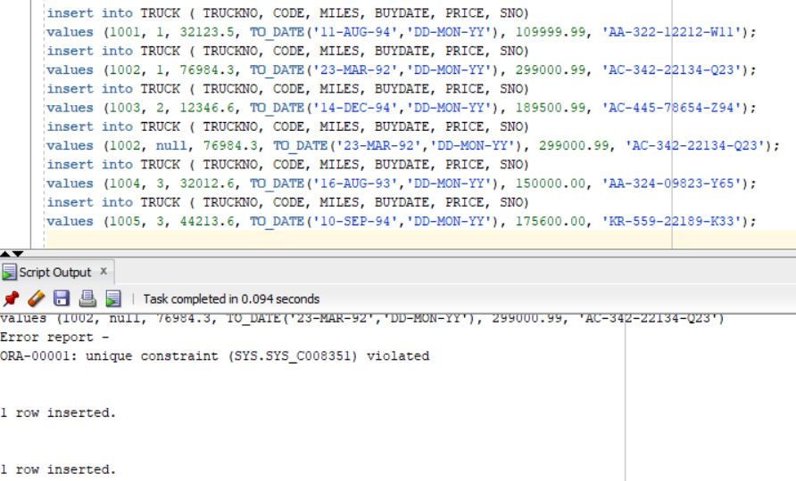

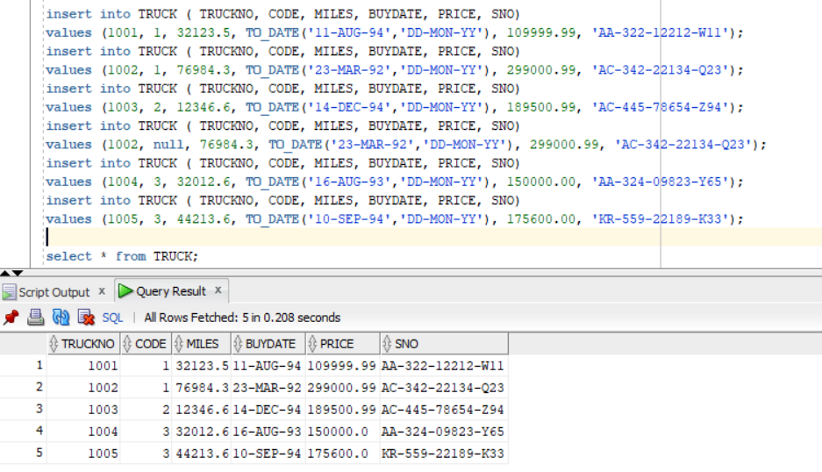

9.2

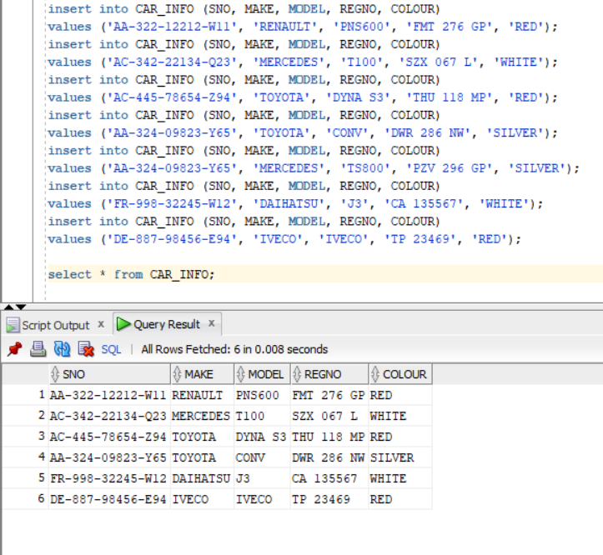

**Question 10**

10.1

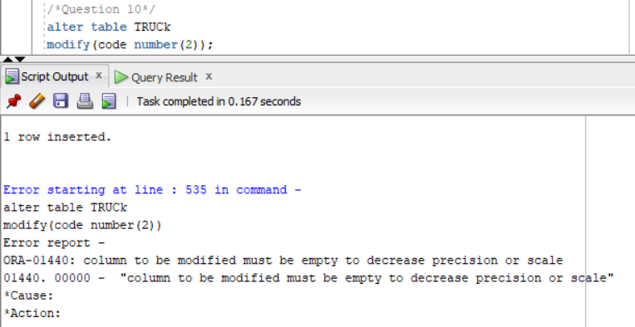

10.2

Add new column

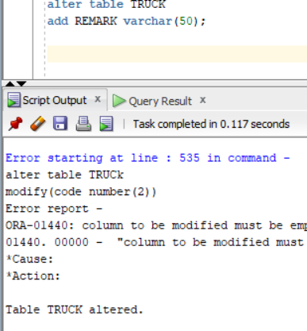

10.3

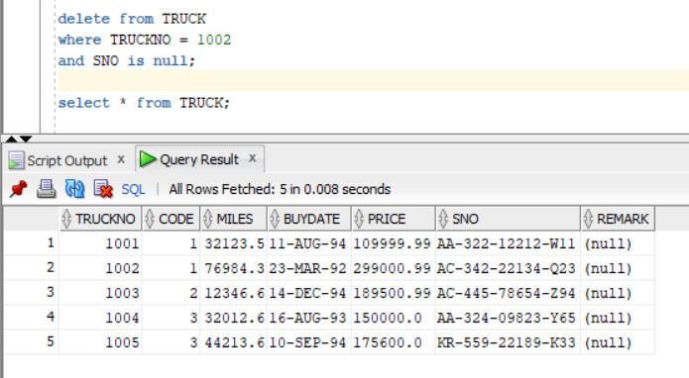

**Question 13**

13.1Use delete:

Delete from truck

Where code = 3;

13.2

Drop table TRUCK;